Proof of Market Funding Call - 2020

The following document provides call guidance and key information on the Grow MedTech Proof of Market funding call for 2020.

Opportunities overview

One of the aims of Grow MedTech is to facilitate collaboration, connect capability and develop partnerships for industry, providing a brokerage role to strategically match companies to researchers for industry driven projects. Although these calls do not fund industry/commercial organisations directly they aim to stimulate and strengthen interaction and collaboration between our partner universities and industry.

Grow MedTech supports medical technology innovation in the Leeds and Sheffield City Regions. It focuses on technology convergence and the de-risking of medical technologies, by bringing together leading medical technology and translational expertise in the Leeds and Sheffield city regions. The programme aims to unlock the full potential of the region and make it a leading area for medical technology innovation and commercialisation in the UK.

Grow MedTech is inviting applications for Proof of Market, projects from academic led teams at partner institutions to advance the development and derisk technologies in order to build confidence for further investment (Figure 1). These calls will support projects that demonstrate close and tangible links with industry and clinical/healthcare sector. These calls have been developed with the aim of accelerating and enhancing innovation in all sectors of medical technologies and medical devices with significant commercial potential and patient benefit. There is a particular focus on digital health and technology convergence.

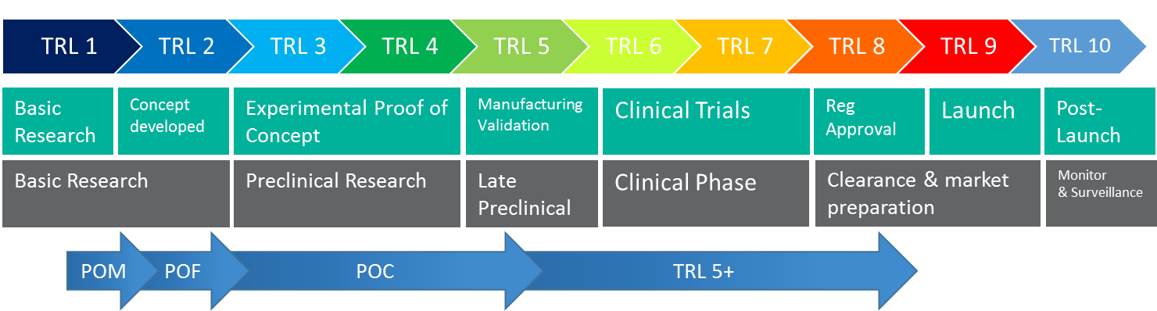
Figure 1: Schematic of Grow MedTech Project formats in relation to TRL.

Grow MedTech supports the development of medical devices including materials, and software, but does not support the development and discovery of pharmaceuticals.

All applications should have a strong emphasis on patient benefit with plans for patient and public involvement. Industry involvement is recommended where possible. Projects leveraging industry or third-party funding to translate research for clinical impact are also important to Grow MedTech.

Application guidance
Due-diligence and de-risking funding:
Funding to enable commercially inspired projects to be validated and de-risked: establishing a market need and enabling further investment to be attracted. Outcomes from this work will be validated and de-risked technology opportunities, with an established market need, subsequently attracting feasibility funding.

Scope of funding
Projects should aim to bring together researchers, clinicians, patients/public and industry. All components are not expected to be present for the duration of the project however, the applicant is advised to consider how they will be incorporated in the medium and longer term.

Proof of Market awards costed up to £5,000 and of a duration of 6 months, are available through this call, which fit with the award scope.

The funding will be responsive and managed by the Technology Innovation Management Team throughout the length of the programme with emphasis on developing critical mass in these activities early on to feed the innovation pipeline.

Eligibility
Applications are invited from academics (from post-doctoral to professorial level) who are based at one of the six Grow MedTech partner universities - University of Bradford, University of Huddersfield, Leeds Beckett University, University of Leeds, Sheffield Hallam University and the University of York. If you are applying as a postdoctoral researcher you will need the approval and signature of your academic supervisor.

How to apply
Applications forms can be provided by and should be co-developed with a Grow MedTech Technology Innovation Manager – for contact details please see: https://growmed.tech/about/#

Completed Proof of Market applications forms should be emailed to info@growmed.tech by the 15th of the month for review in that month’s review meeting.

What can be funded?
- Patient, carer, and public consultation workshops to identify and validate the need for a particular project or technology
- Clinical consultation workshops with clinicians and healthcare professionals to validate the need for a particular project or technology
- Consultation or technology showcase workshops with regional and national representative bodies- including clinical commissioning groups (CCGs), NHS organisations, representative networks, large charities, regional third sector organisations or potential industry partners
- Developing technology road maps and routes to commercialisation
- Market, opportunity and competitor analysis
- IP landscaping and advice on IP protection
- Regulatory pathway guidance

What will not be funded?
- Staff costs will not normally be supported
- Funding for conference attendance
- Support for intellectual property protection, exploitation or freedom to operate reviews. It is envisaged that as the respective institutions and/or their partners will own the IP generated through this process, that they will provide the required IP support as part of the co-investment process
- Development of new drug and pharmaceuticals is outside the scope of Grow MedTech and will not be supported.
- This call does not directly fund industry/commercial organisations. However, proposals from University partners which demonstrate evidence of an industry-defined market need and projects with industry partner contribution are encouraged. Strong links with clinical or healthcare workers is also strongly encouraged. Grow MedTech can provide a brokerage role to strategically match researchers with companies and clinical partners for industry/clinical driven projects.

How will my application be assessed?
Applications will be reviewed by the Grow MedTech Innovation Management team on a monthly basis and will be assessed on:
- Scope in relation to Grow MedTech
- Quality of Proposal
- Realistic and achievable plan of work and objectives (including PPI activities)
- Potential to meet a clinical need/potential for patient benefit
- Potential Commercial opportunity
- Realistic follow-on plan
- Development of new collaborations
- Ability of the project team to deliver

Some additional things to think about:
- Include details on the maturity of any research/technology/intervention under development, the translational aspects, clinical impact, the patient benefit and the impact of healthcare provision if known
- Has there been any industry support/interaction for this project, if not then future plans for engaging with industry

Applicants will receive feedback and be informed of the award outcome within a month of submission unless otherwise stated.

Following approval a Grow MedTech Technology Innovation Manager will work with successful applicants throughout the life of the project to ensure it delivers to time and on budget.

Key dates
Completed Proof of Market application forms should be emailed to info@growmed.tech by the 15th of the month for review in that month’s review meeting.

